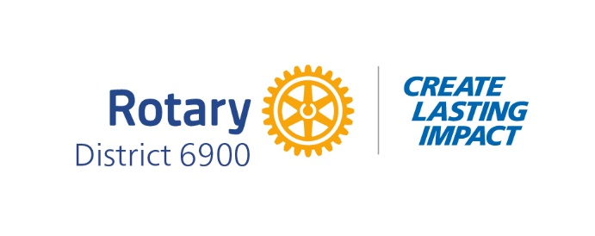
Club Leadership Learning Seminar
Columbus Convention & Trade Center
Saturday, April 11, 2026
8:00 am – 12:30 pm

8:00 am – 8:30 am Registration

8:30 am – 9:30 am General Assembly and Breakfast

Call to Order DGE Cynthia Dorsey Edwards

Invocation Walter Marria, Jr.

Pledge DGN Buck Buchanan

4 Way Test DGND Amy Benton

Introduction of Mayor Alan Harkness, President
of Columbus RC of Columbus

Welcome Mayor Skip Henderson

Welcome Rotarians DLF Andrè Hadley Marria

Governor’s Report DG Steve Ivory

DGE Address to Assembly DGE Cynthia Dorsey Edwards

Introduction of Assembly
VIP’s and Workshop Presenters

9:45 am – 10:45 am Workshops

Room 201 Club Awards Criteria – 2026-2027
DGND Amy Benton

Room 202 From Georgia to the Globe: Rotary’s Path to Peace
AG Cedric Hill; District Friendship Exchange Chair Ada Wikina

Room 203 Public Image Essentials – Telling Rotary’s Story the Right Way
District Public Image Chair – Nick Ramey

Room 207 Club Finances and Administration
PDG Cheryl Greenway and District Executive Manager Mandy Timmons

Room 208 Serving Youth and Young Adults – RYLA, Laws of Life, Rotary Youth Exchange, GRSP, Be the Voice, Next Level Living Students
2025-2026 DLF Stephanie Windham - Facilitator

Room 209 Membership – Strategies for Attraction & Smart Growth
District Membership Chair Audley Knight and Zone Coord./PDG Mary Ligon

Room 210 Foundation – EVERYTHING You Need to Know About Community Grants
District Community Grants Chair – Kay Williamson

10:45 am – 11:00 am Break

11:00 am – 12:00 pm Workshops

Room 201 Calling All Assistant Governors
DLF Andrè Marria and DGND Amy Benton

Room 202 President Nominees
District Governor Nominee Buck Buchanan

Room 203 AI and Social Media Mastery – Smarter Strategies for Rotary Public Image
District Public Image Chair – Nick Ramey and his PI Team

Room 207 The Rotary Foundation – Global Grants, International Service and PolioPlus
District Foundation Chair PDG Bob Hagan, Mike Mudd, Lee Hollingsworth

Room 208 Strategic Planning & Succession Planning + The Rotary Action Plan –
How Planning Makes Us Better
Zone 34 Coordinator Mary Ligon, PDG

Room 209 Membership – Strategies for Attraction & Smart Growth
District Membership Chair Audley Knight

Room 210 Foundation – EVERYTHING You Need to Know About Community Grants
District Community Grants Chair Kay Williamson

12:10 pm – 12:30 pm General Assembly
Closing Remarks & Door Prize – DGE Cynthia Dorsey Edwards

**Bring Your Laptop or Tablet – Some Workshops Will Be Interactive**
**Most Workshops Are Not Repeated**

